**R00182510 Machine Vision Assignment 1**

Both Task 1 and Task 2 were implemented in a single file R00182510_MV_A1_Code.py

To execute Task_1, in the main() function please assign the value ‘Task_1’ to the execute variable. To execute Task_2, in the main() function please assign the value ‘Task_2’ to the execute variable.

**Task 1**

Implementation of scale and rotation invariant point feature extraction algorithm inspired by SIFT to identify a set of interest points in an image together with their respective scales and rotations.

All the output images from Task-1 will be saved to a folder as given in the ‘picPath’.

# The output path to save all the figures/output images generated in Task 1  
picFolderName = 'R00182510_Task1_Output_Images'  
picPath = os.path.join(os.getcwd(),picFolderName)  
if not os.path.exists(picPath):  
 os.makedirs(picPath)

**Subtask B – Output Images**

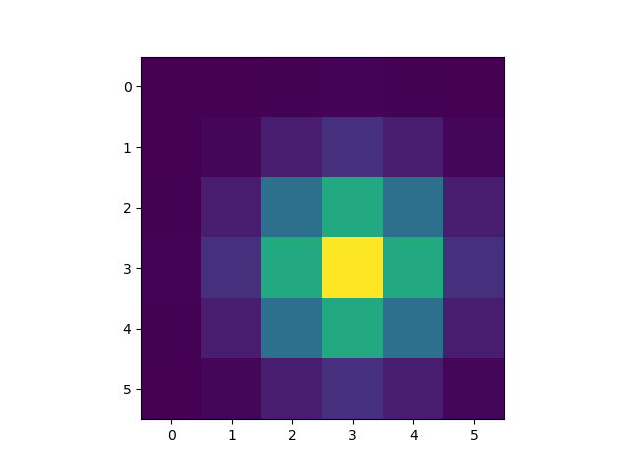Gaussian Kernel 1

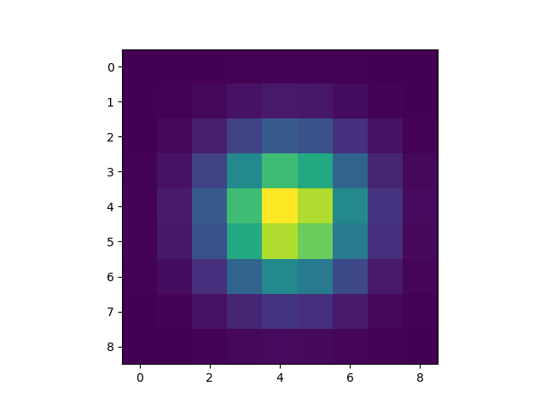  
Gaussian Kernel 2

Gaussian Kernel 3

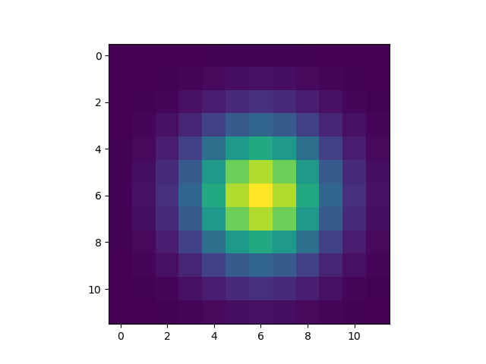

Gaussian Kernel 4

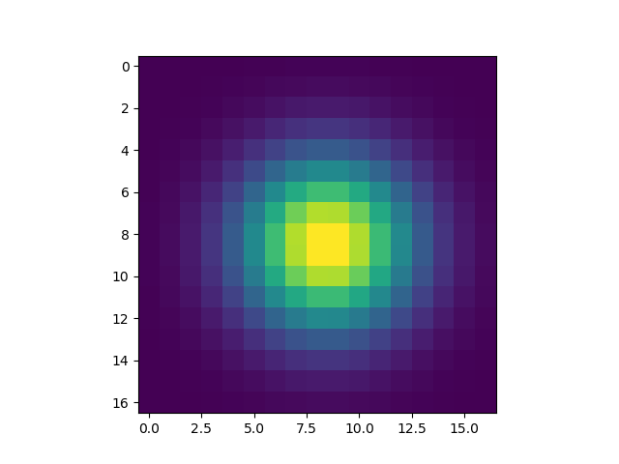

Gaussian Kernel 5

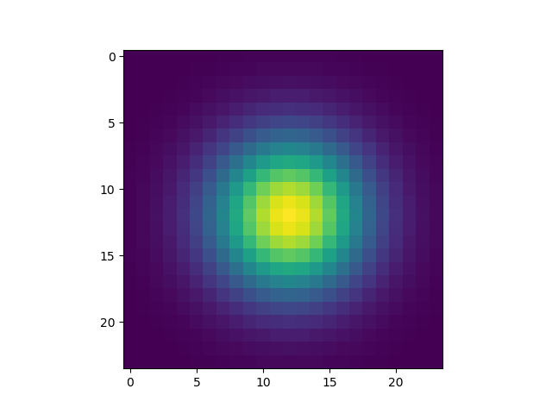

Gaussian Kernel 6

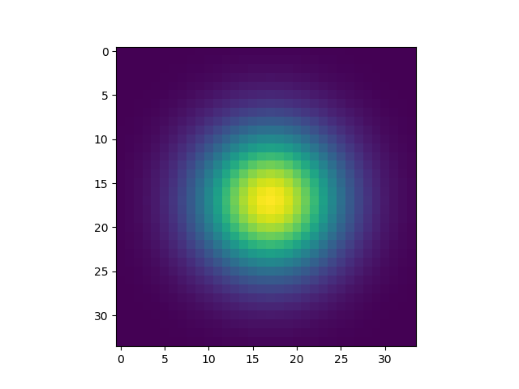

Gaussian Kernel 7

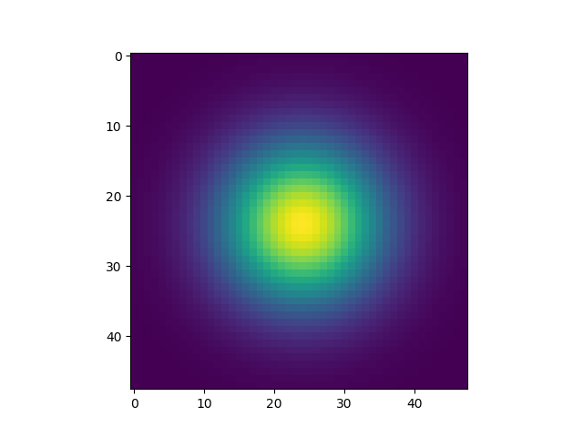

Gaussian Kernel 8

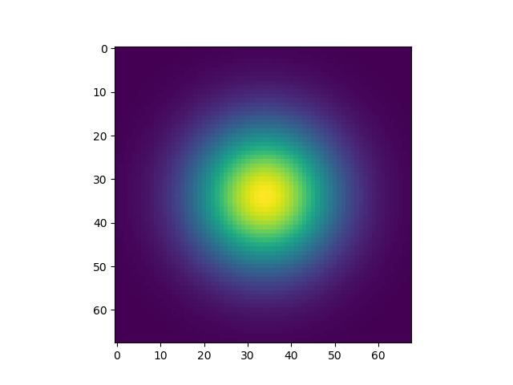

Gaussian Kernel 9

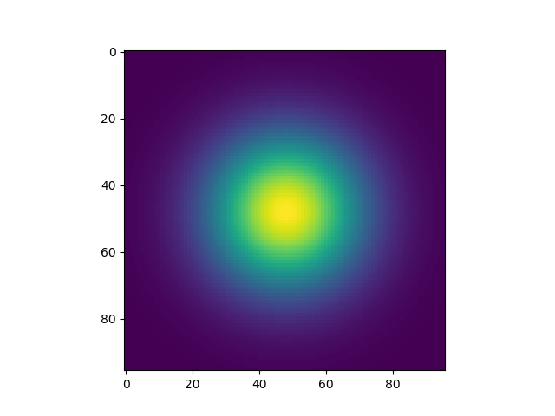

Gaussian Kernel 10

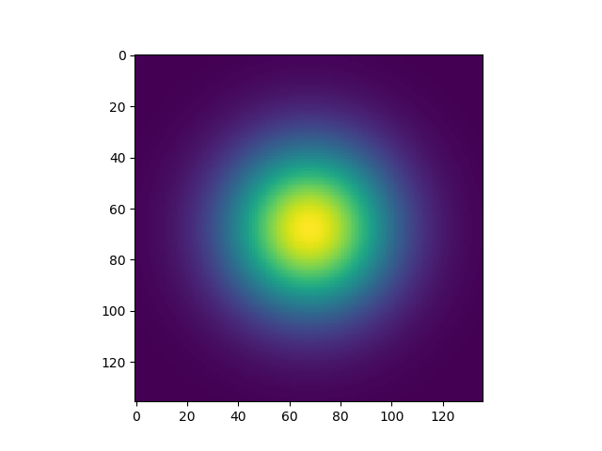

Gaussian Kernel 11

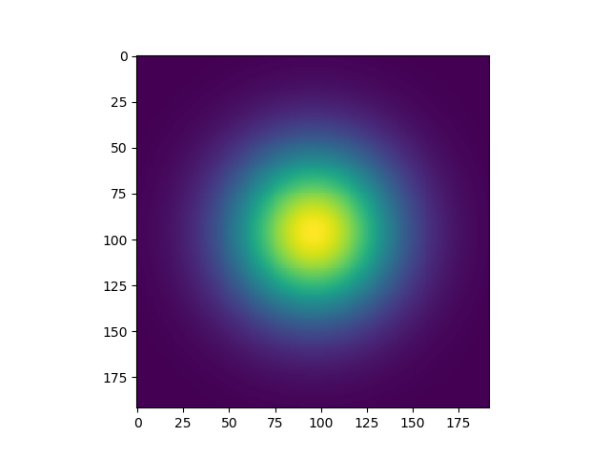

Gaussian Kernel 12

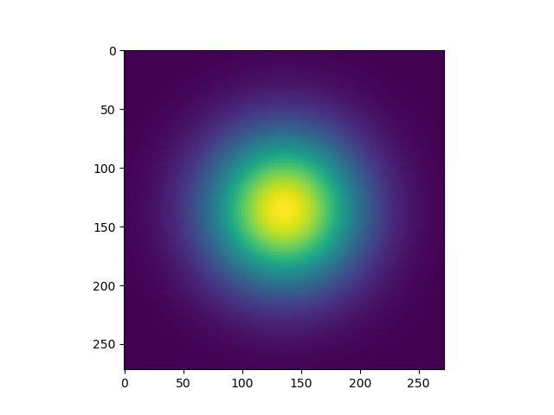

Gaussian Image 1

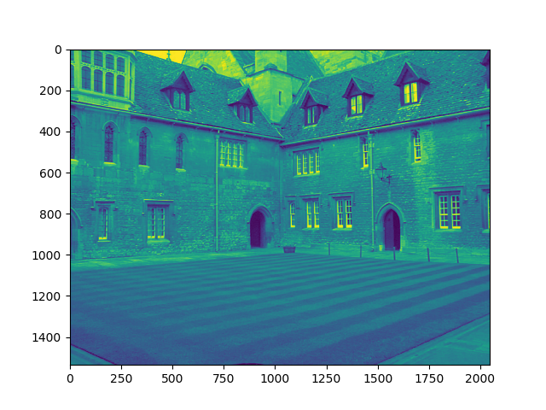

Gaussian Image 2

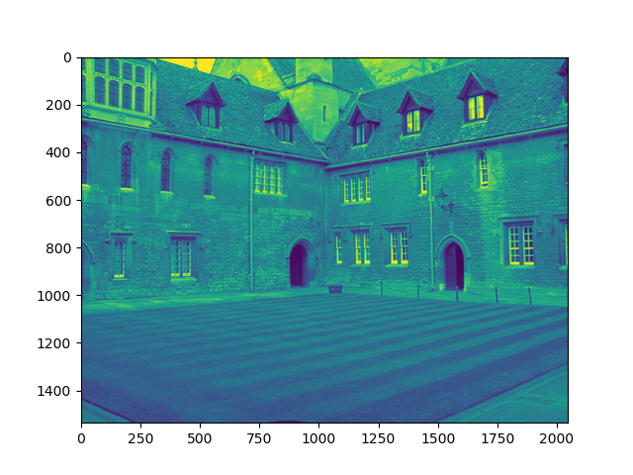

Gaussian Image 3

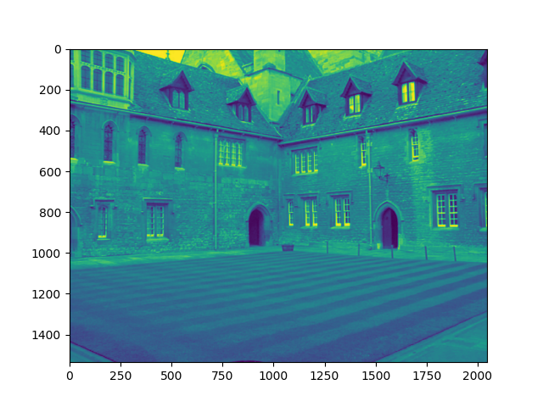

Gaussian Image 4

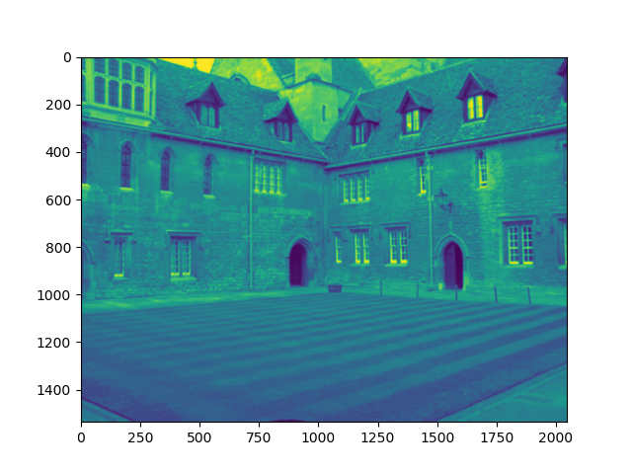

Gaussian Image 5

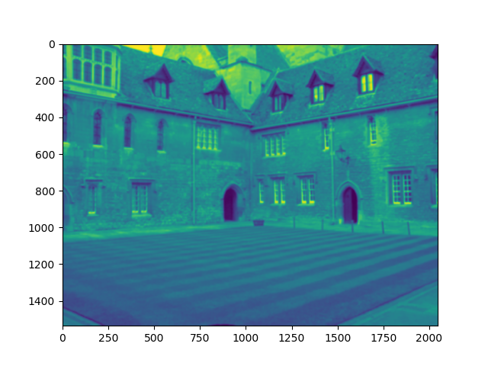

Gaussian Image 6

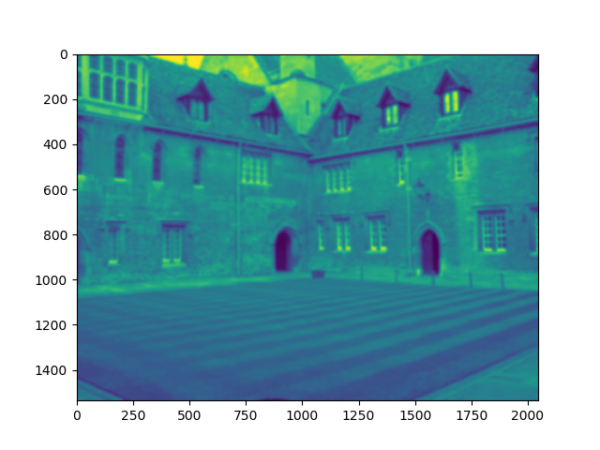

Gaussian Image 7

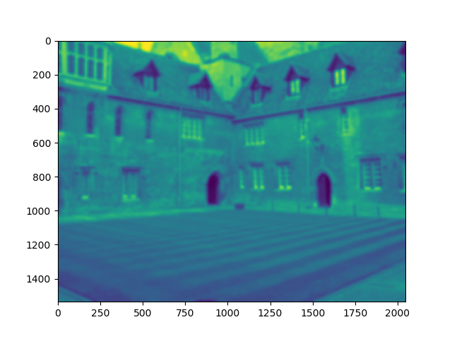

Gaussian Image 8

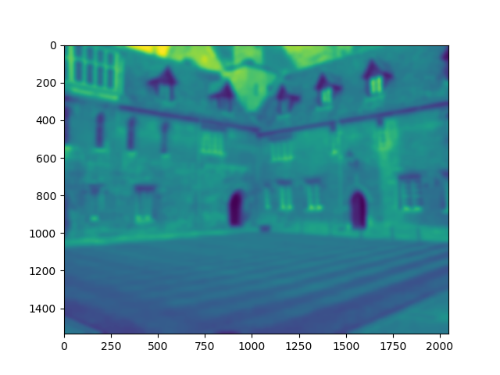

Gaussian Image 9

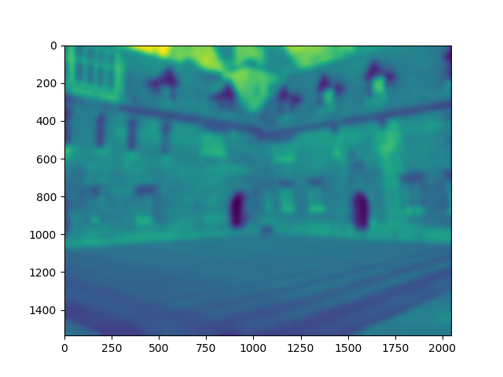

Gaussian Image 10

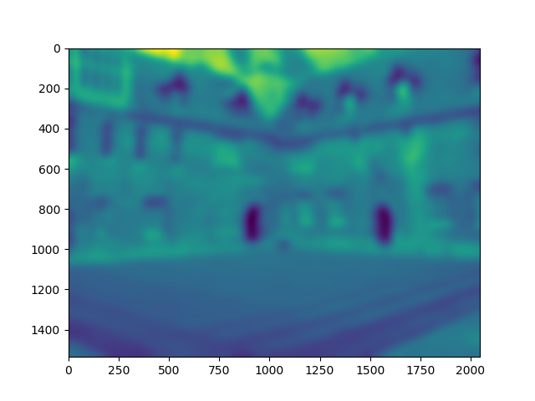

Gaussian Image 11

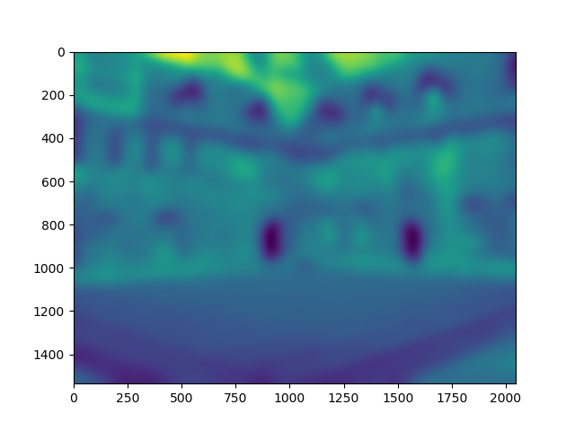

Gaussian Image 12

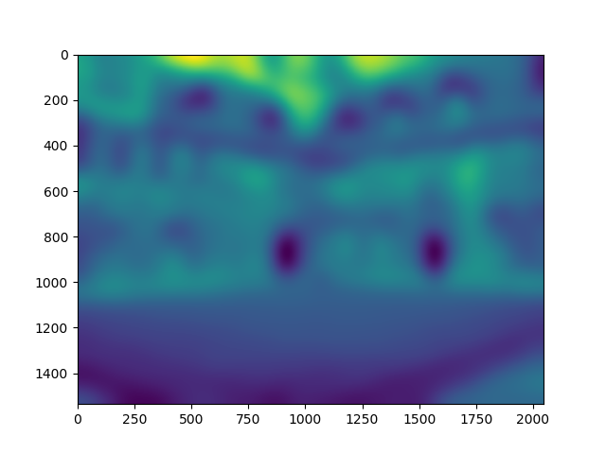

**Subtask C – Output Images**

DOG Image 1

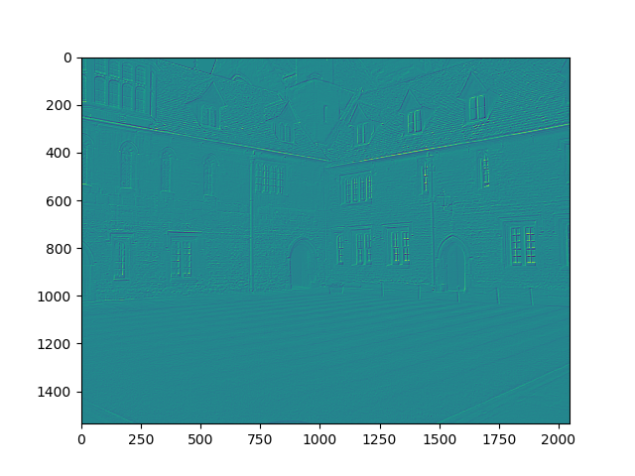

DOG image 2

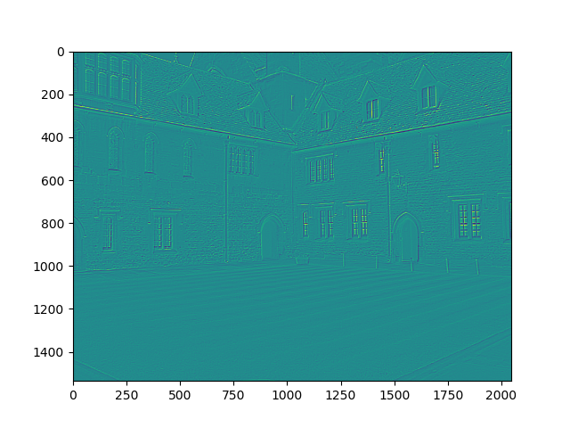

DOG Image 3

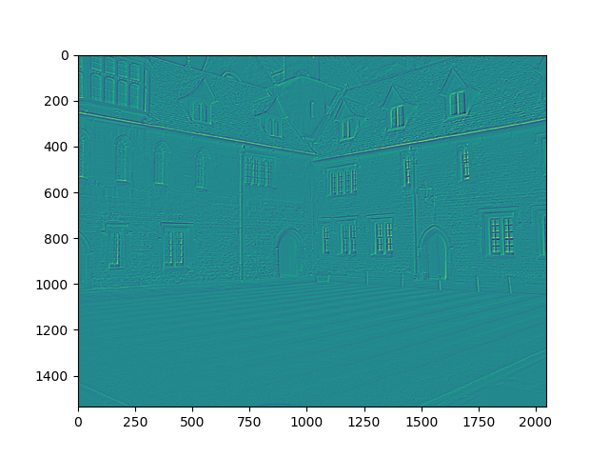

DOG Image 4

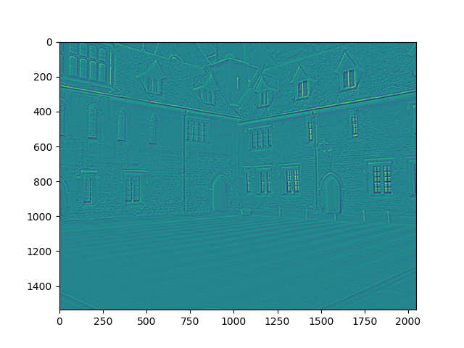

DOG Image 5

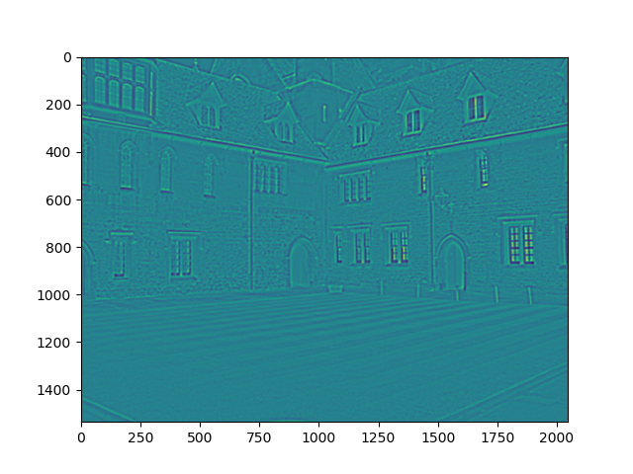

DOG Image 6

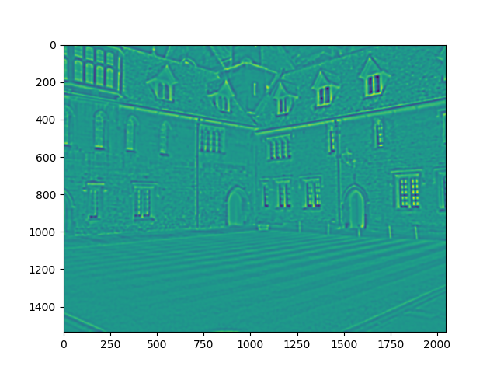

DOG Image 7

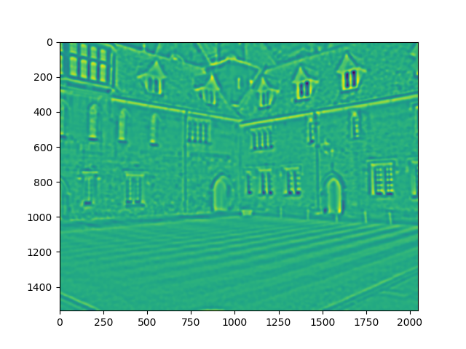

DOG Image 8

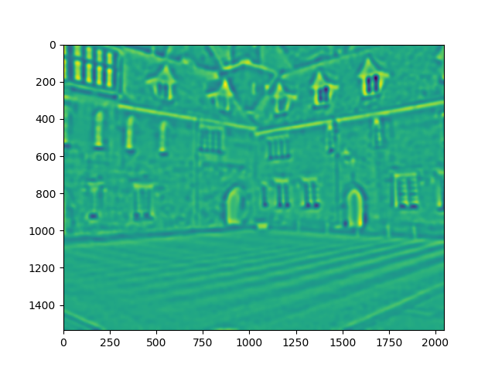

DOG Image 9

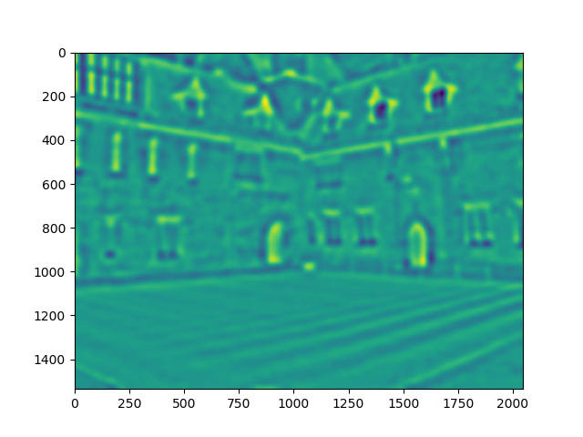

DOG Image 10

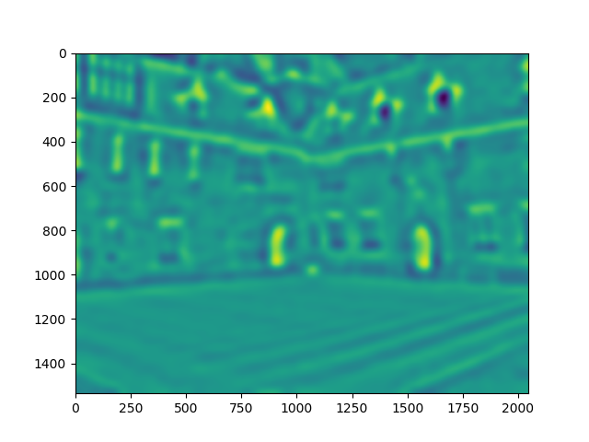

DOG Image 11

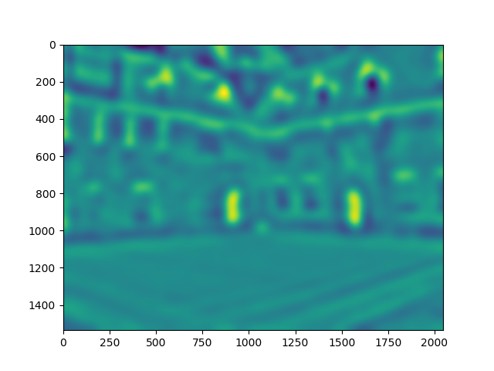

**Subtask D**

No. of Key-points generated: 4449

**Subtask E Output Images**

Derivative-X Image 1

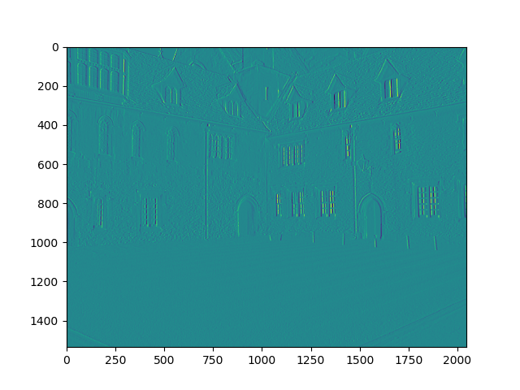

Derivative-Y Image 1

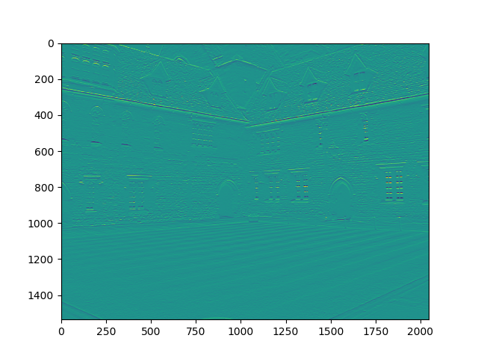

Derivative-X Image 2

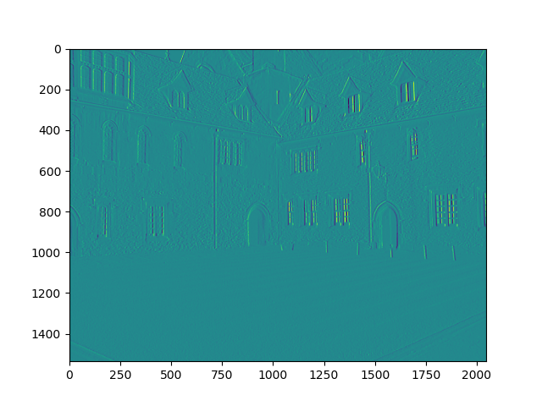

Derivative-Y Image 2

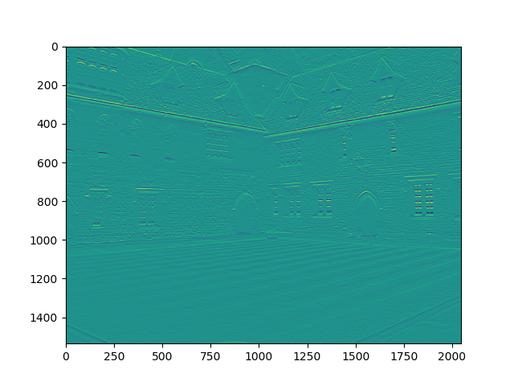

Derivative-X Image 3

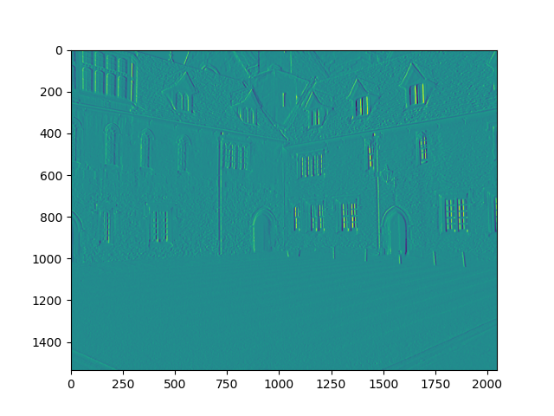

Derivative-Y Image 3

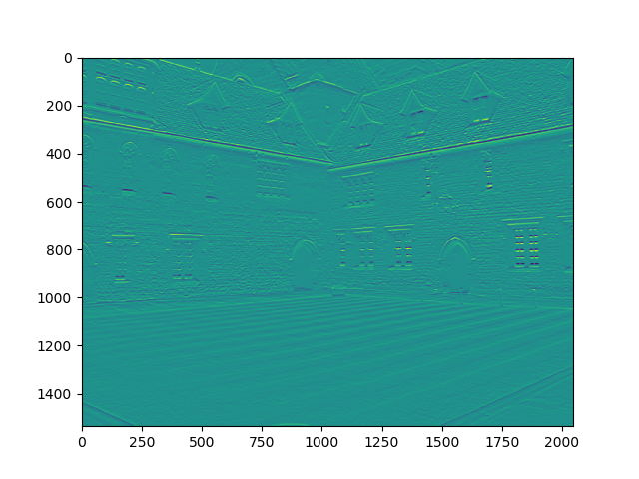

Derivative-X Image 4

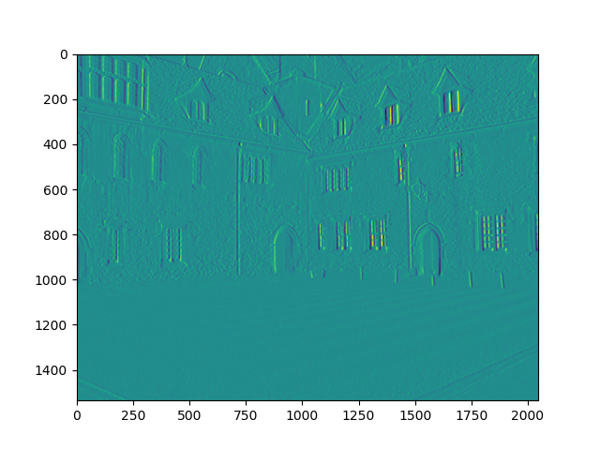

Derivative-Y Image 4

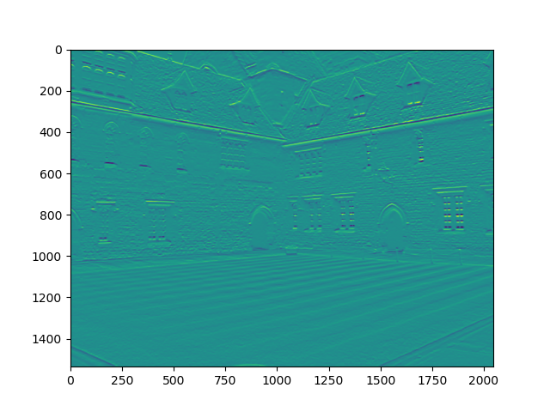

Derivative-X Image 5

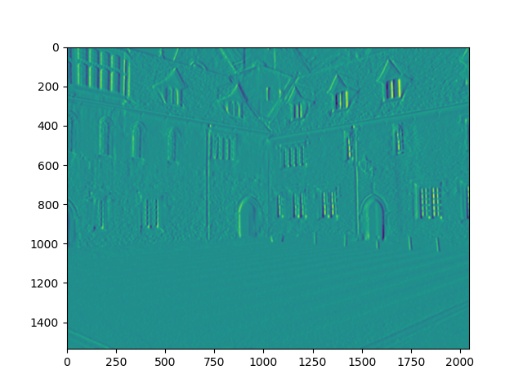

Derivative-Y Image 5

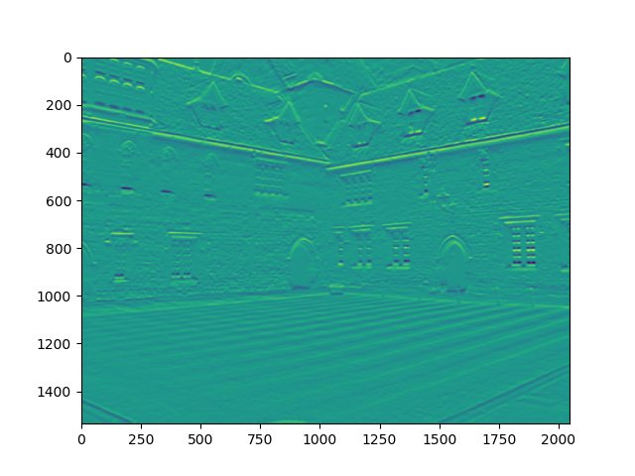

Derivative-X Image 6

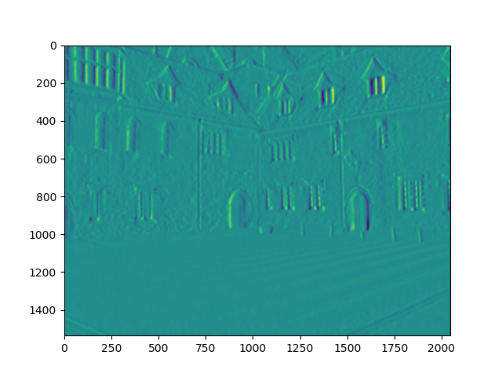

Derivative-Y Image 6

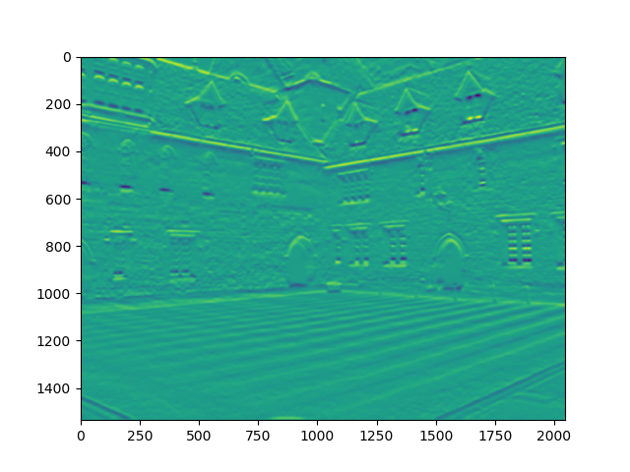

Derivative-X Image 7

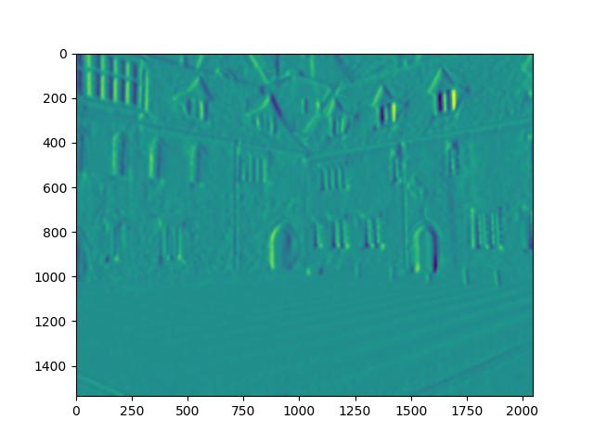

Derivative-Y Image 7

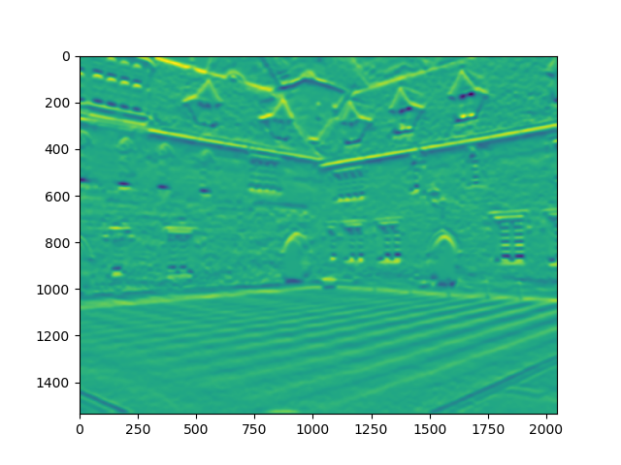

Derivative-X Image 8

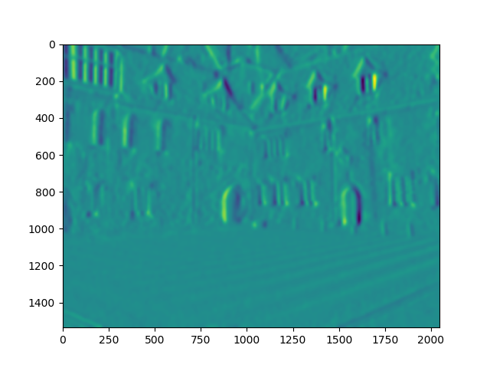

Derivative-Y Image 8

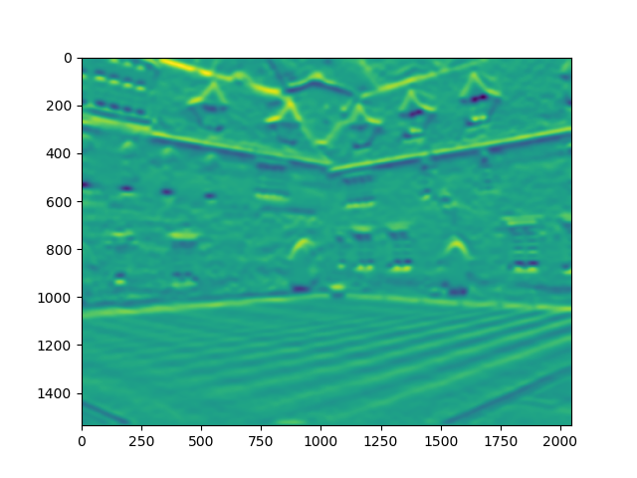

Derivative-X Image 9

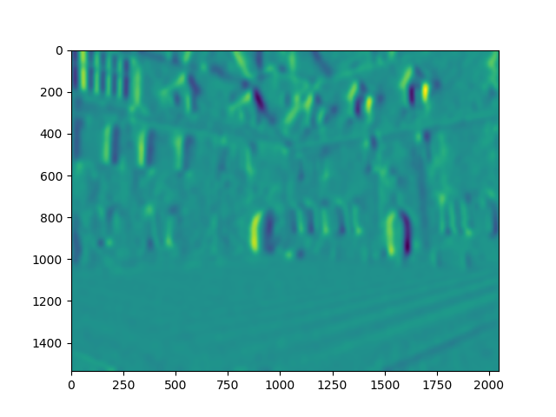

Derivative-Y Image 9

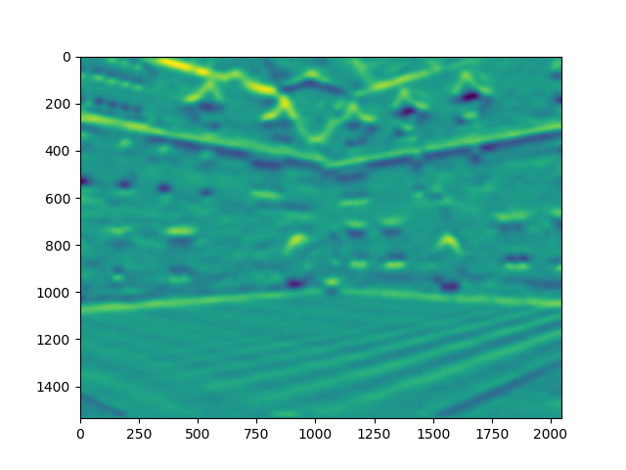

Derivative-X Image 10

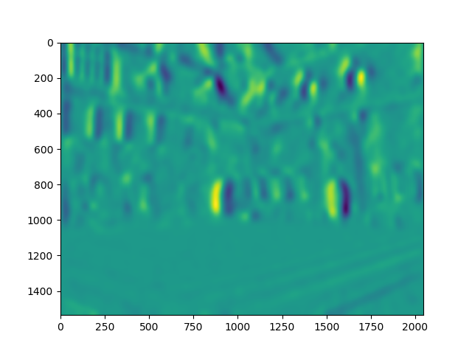

Derivative-Y Image 10

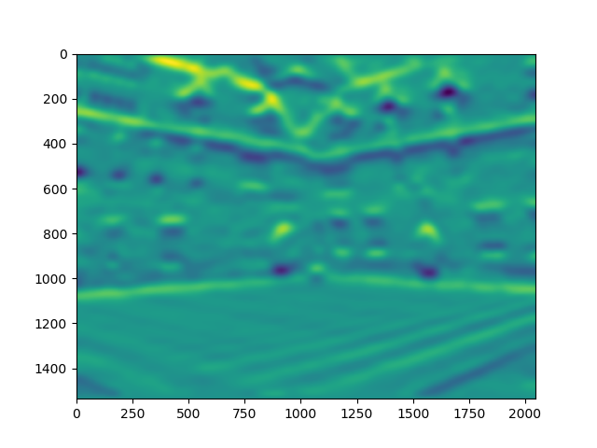

Derivative-X Image 11

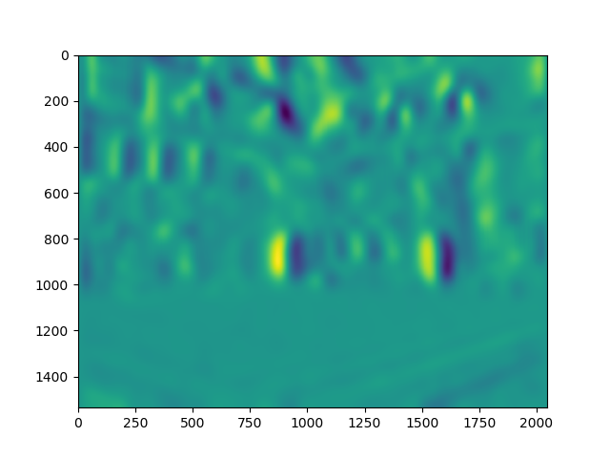

Derivative-Y Image 11

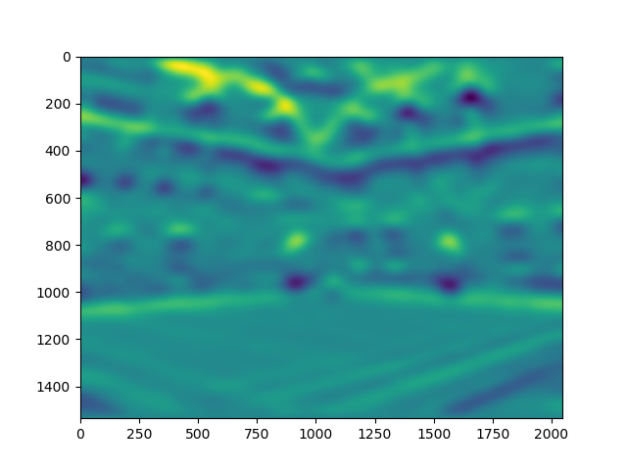

Derivative-X Image 12

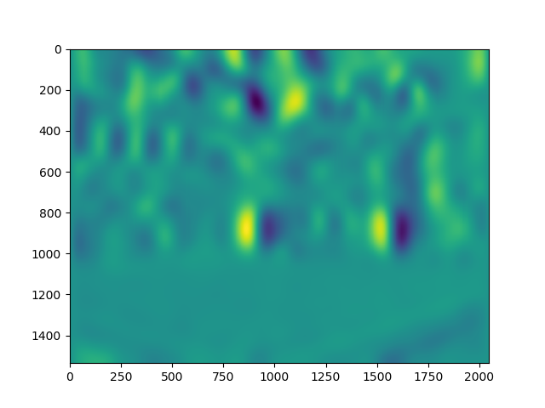

Derivative-Y Image 12

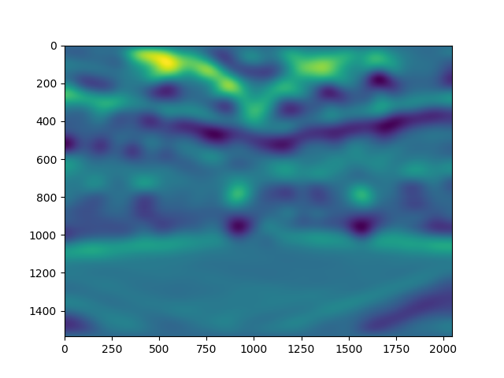

**Subtask G**

Final image with key-points

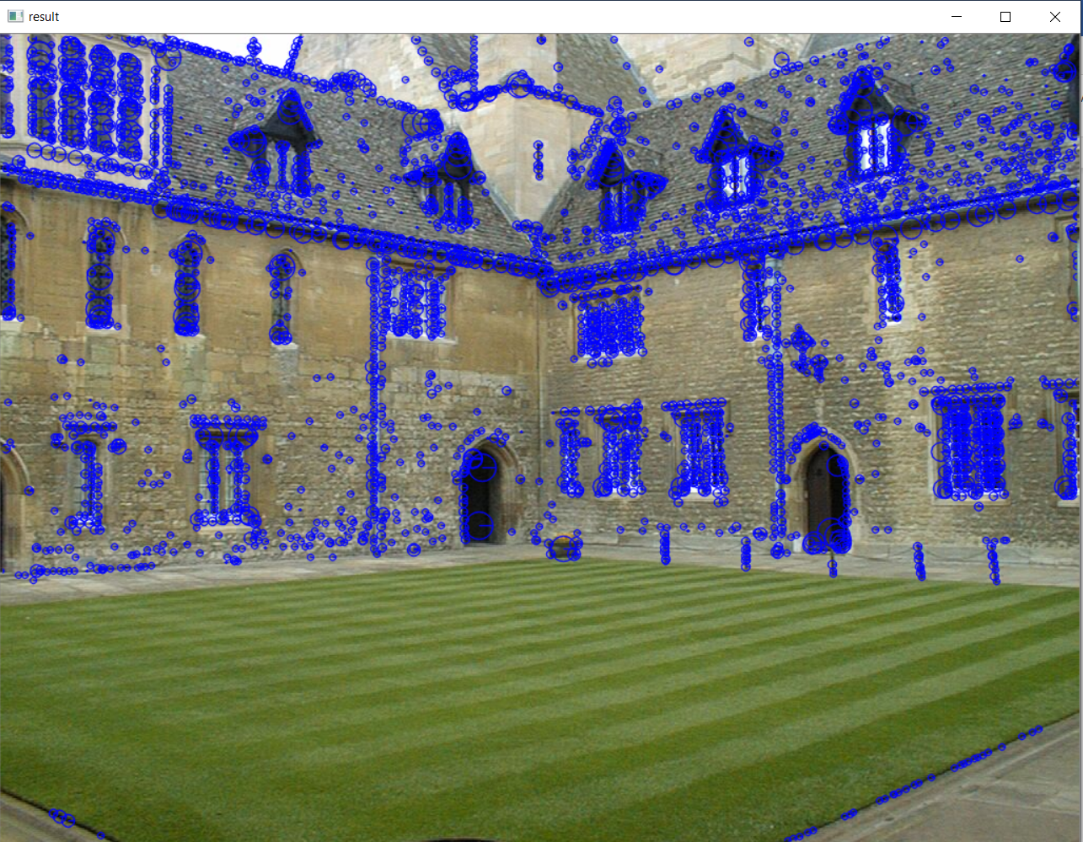

**Task 2**

Implementation of a correlation-based area matching algorithm to find a patch extracted from one image in a second image

**Subtask B Output Images**

Image-1 with a rectangle drawn around the area of interest

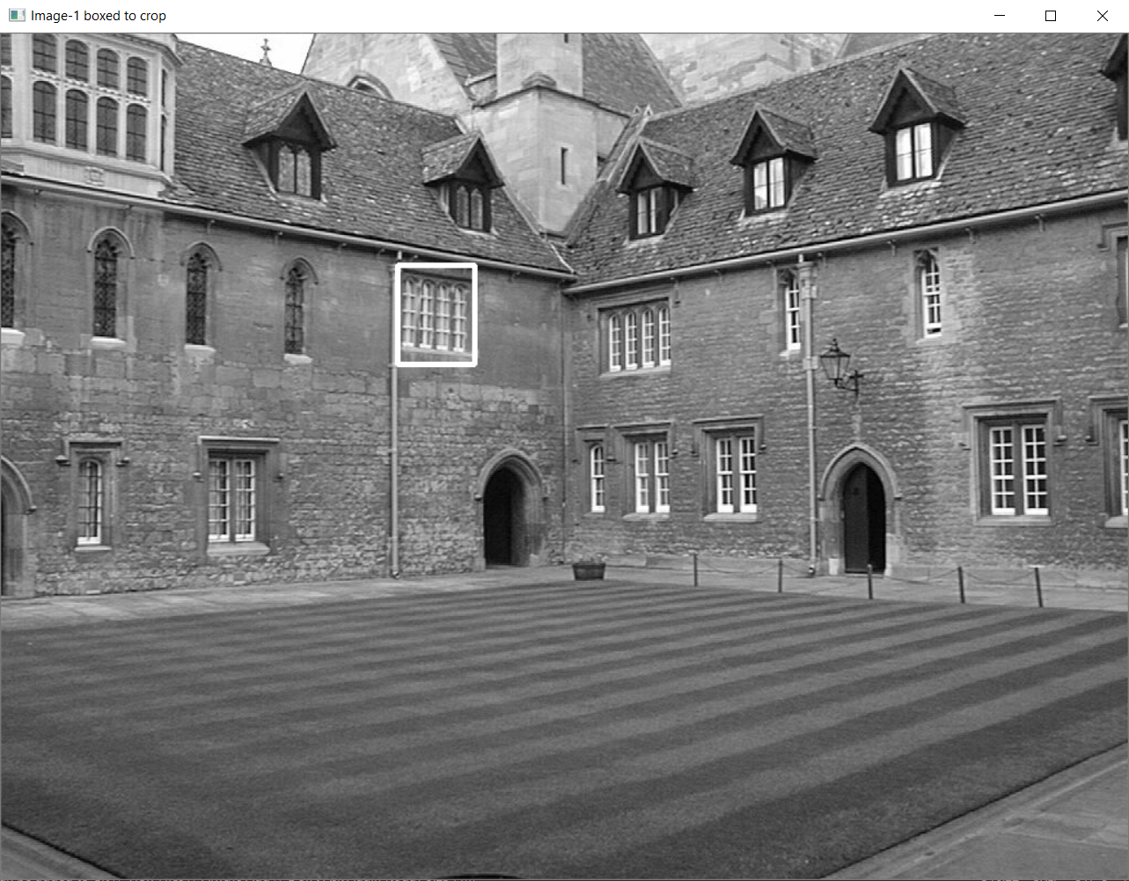

Cropped patch from Image-1

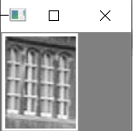

**Subtask C Output Images**

Cross correlation between all patches of Image-2 and the cropped patch from Image-1

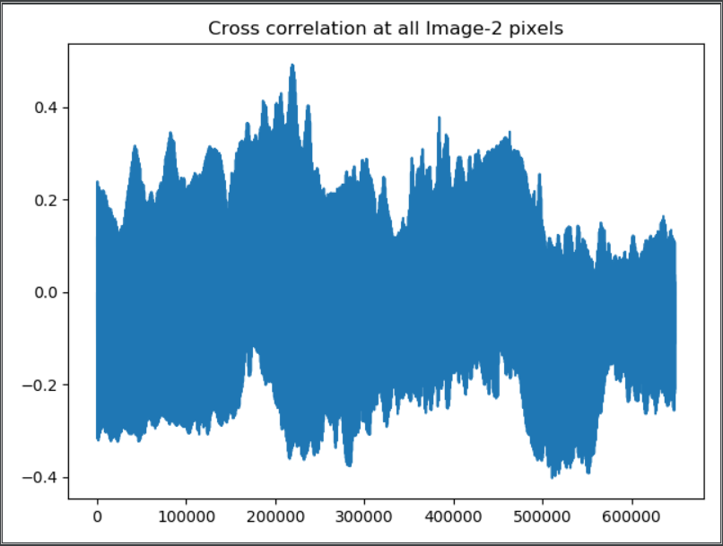

Matched area in Image-2 indicated by a rectangle